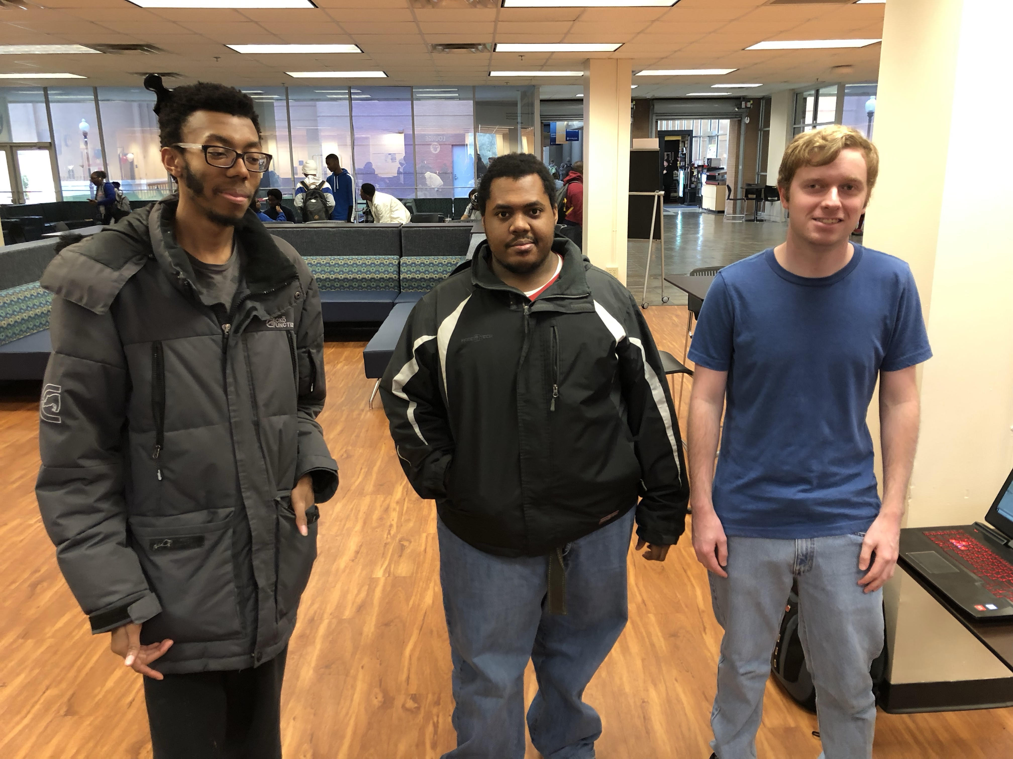

The great majority of the time I was coding attempting to fix a crucial logical error that returned over the night before… nothing dealt damage! (… except for DOTs as they’re handled in a separated manner) I managed to make the damage pass between objects again by the end of the event, however it was inconsistent. Still, 1 person played my game.  
  
They somehow came across a problem where after one of my characters dies and does their respective animation, the character disappears if the player attempts to attack after that. Beyond that, they said that they really liked the game for the mechanics within it despite the inconsistent state.

As of the time I began writing this, the inconsistent damage dealing has been fixed. There were a couple structural deficiencies in my code that I did not realize, and it turned out my hitboxes did not stay active as long as they should have. I made sure my children classes had versions of functions the parents had but they did not at the time, and I made sure that the hitboxes stay active throughout any attack’s animation. Also, I had to make sure that the hitboxes did not continuously deal damage.